**02 May 2024**

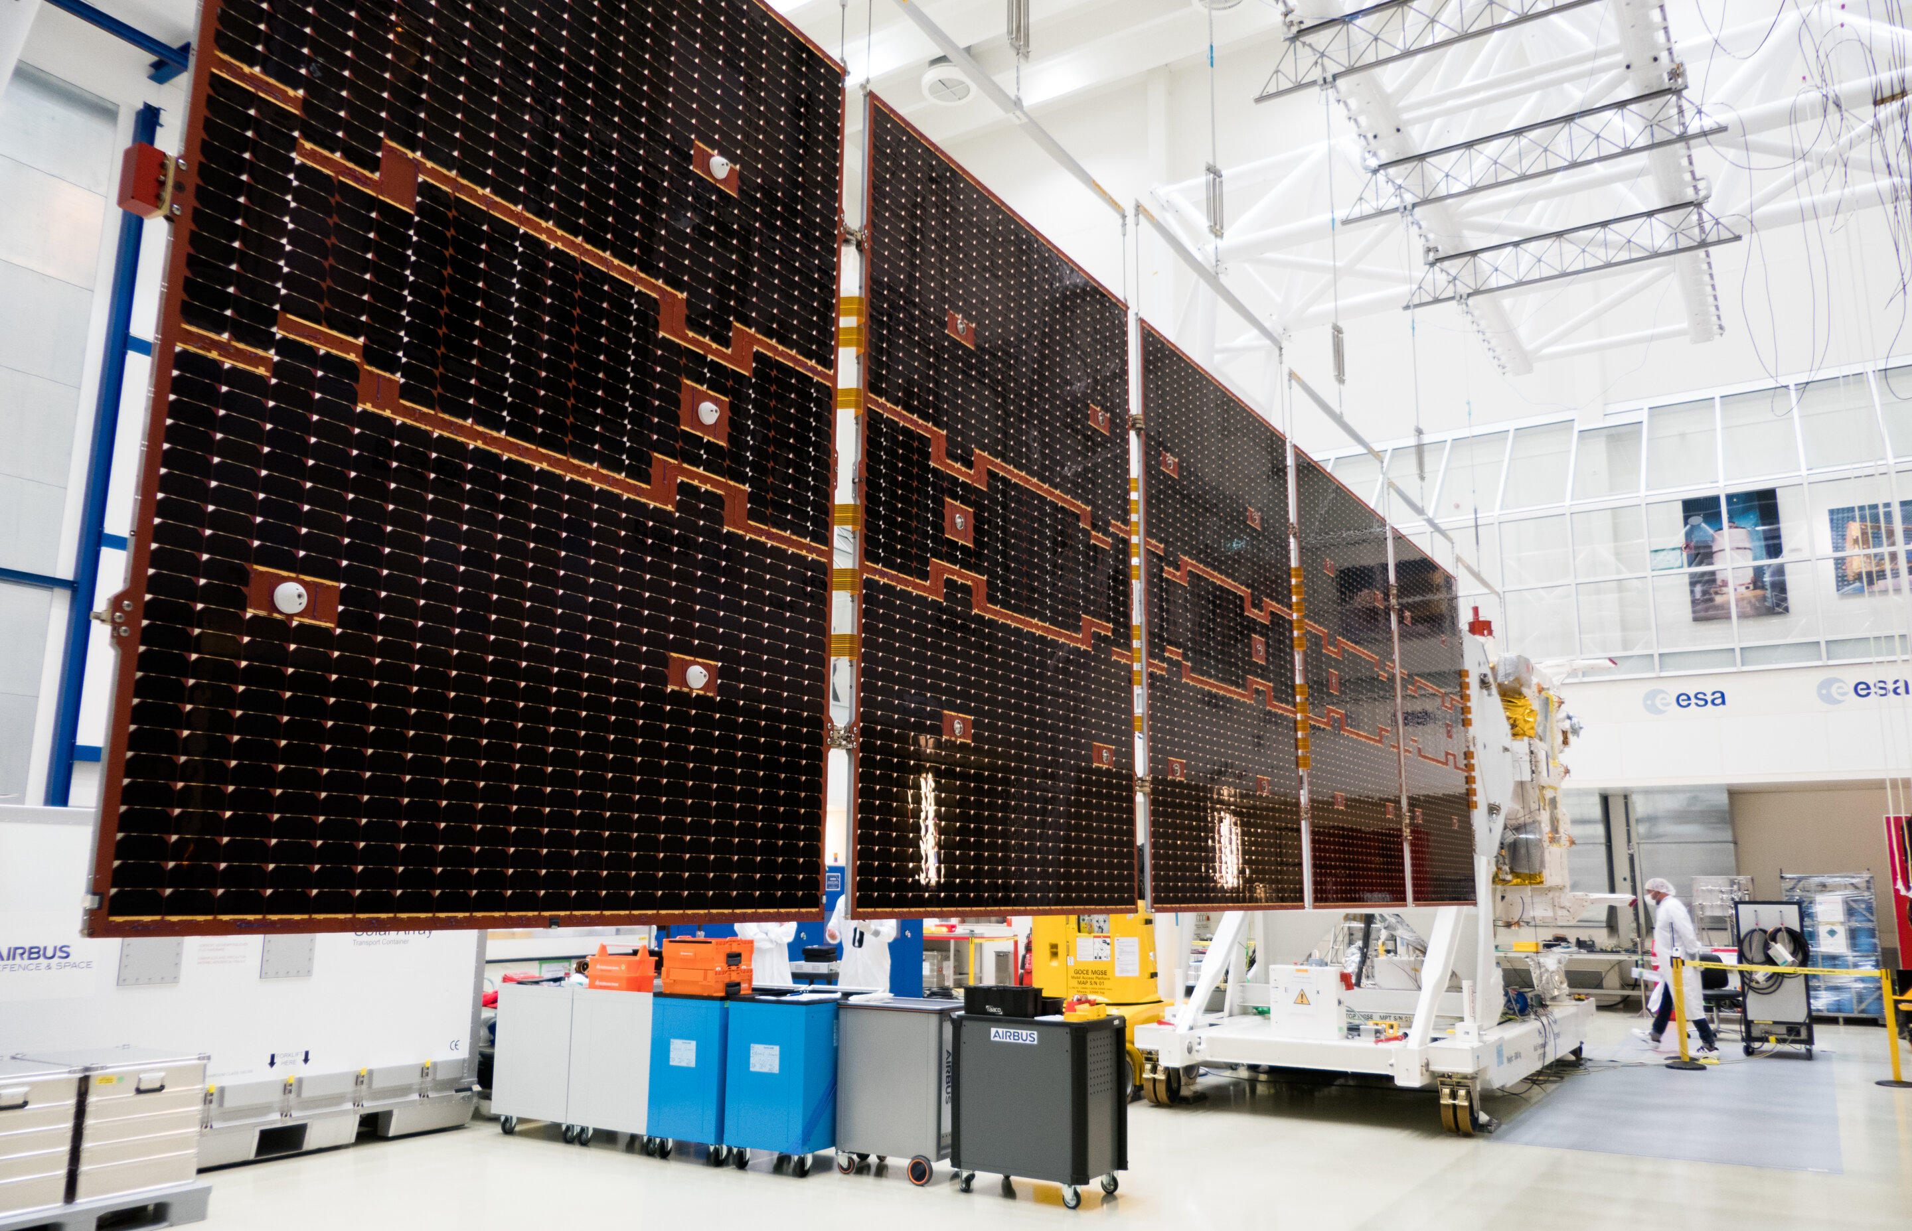

(Picture credits: *ESA–M. Cowan*)

***Falcon 9 Block 5 Launch* / *EarthCARE mission***

**Space agency/country:** SpaceX

**Mission:** *EarthCARE*

On 02 May 2024, SpaceX launched its *Falcon 9* rocket from Space Launch Complex 4E in California, USA. Its payload, the *EarthCARE* mission, is a joint project between the European Space Agency, the Japanese Aerospace Exploration Agency and the US National Institute of Information and Communications Technology. The main aim of this mission is to conduct studies of the global profiles of aerosols, clouds and precipitation properties, combined with radiative fluxes and heating rates.

**For more information:**

<https://nextspaceflight.com/launches/details/960>

<https://egusphere.copernicus.org/preprints/2023/egusphere-2022-1476/>